1. **Data Import**
   1. Download **northwind-db.sql** from classroom
   2. Open XAMPP and Click **Explorer**
   3. Copy downloaded database to **mysql** folder.
   4. Open Shell from XAMPP Admin Panel.
   5. Create database **<yourname>northwind** and exit

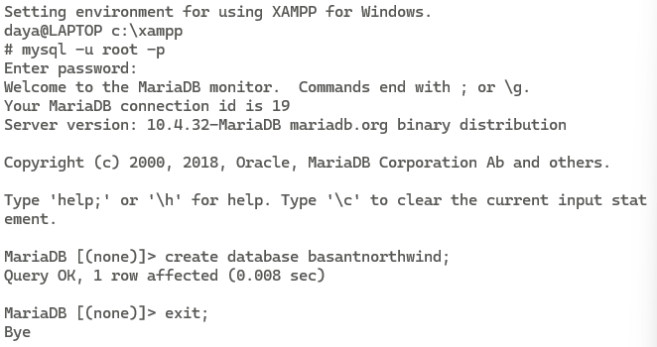

* 1. Import database in **<yourname>northwind** using following command at SHELL **Query:**

1. Connect to database using command  **Query:**

1. Use **<yourname>northwind** database using
   1. QUERY:

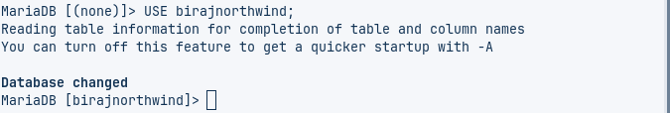

* 1. QUERY:

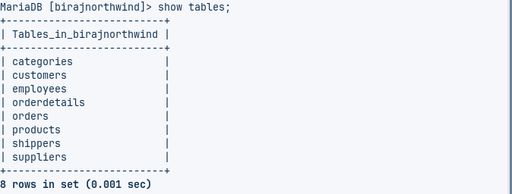

* 1. Check attributes and constraints in each tables i.e. **DESCRIBE <tablename>**

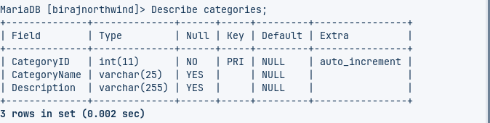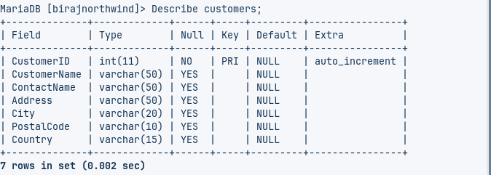

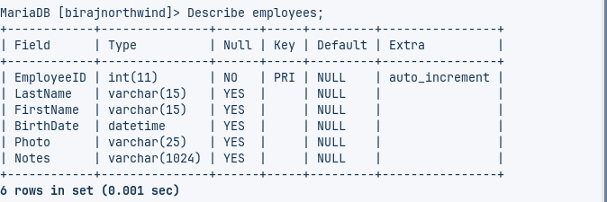

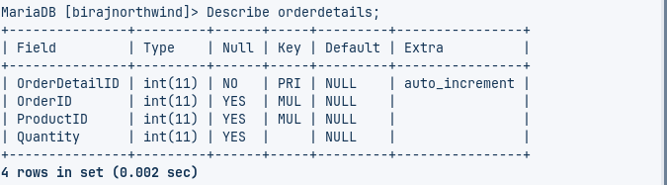

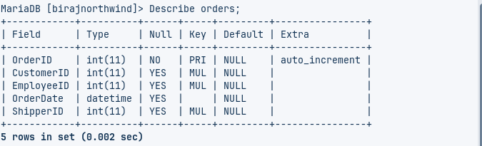

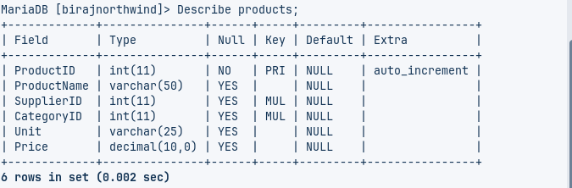

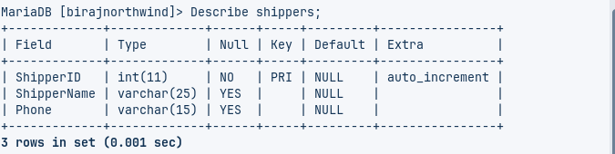

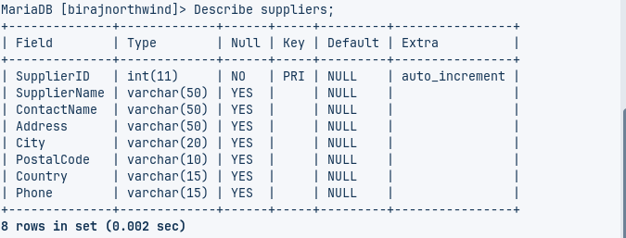

1. **Data MANIPULATION Languages (DML)**
2. Perform UNION of customers and employees relation. (i.e. only matching attributes)

Query:

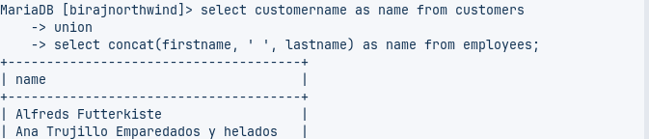



1. Perform UNION ALL of customers.contactname and employee.fullname

Query:

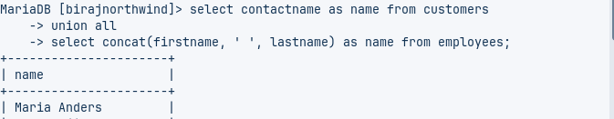



1. List all customers from Mexico and Austria using UNION

Query:

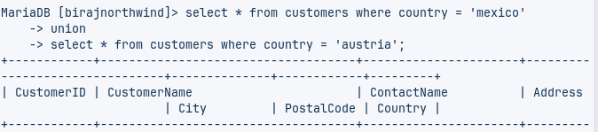

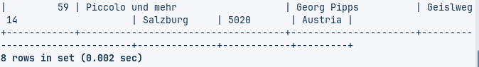

1. List all customers of USA not having same name as of customers from UK

Query:

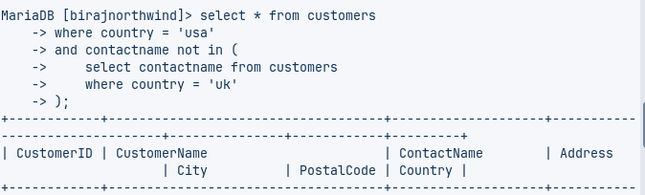

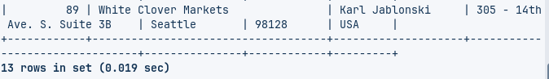

1. Create view cust by selecting only 4 attributes from customers

Query:

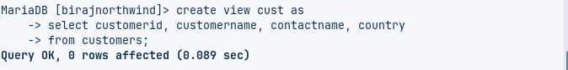

1. Join Products with Categories and Suppliers to create a view named **productinfo** with productID,Name,Unit, Price from products and all attributes from categories and suppliers

Query:

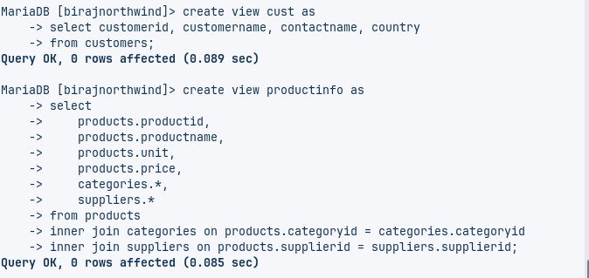

1. Find name and count of Categories from productinfo  
   Query:

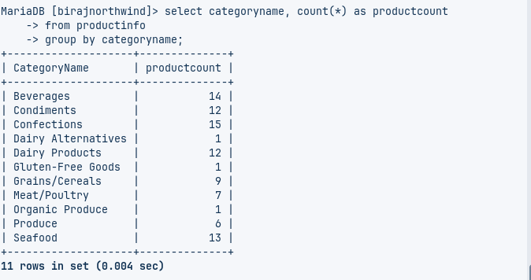

1. Find all products that have suppliers from North America in **productinfo**  
   Query:

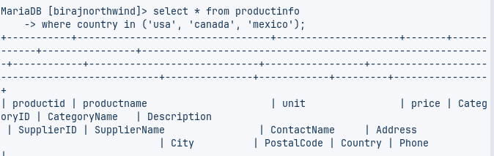

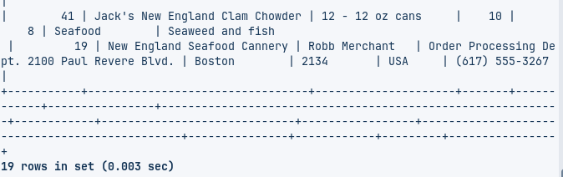

1. Find all products that have price lower price than Average price from **productinfo**Query: **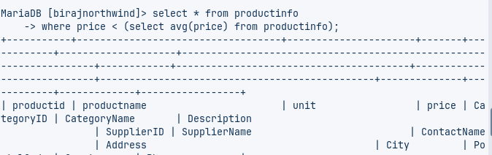  
   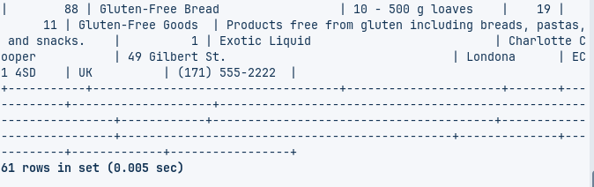**
2. Join orders with customers, employees and shippers to create a view as **orderinfo**.  
   Query:  
     
   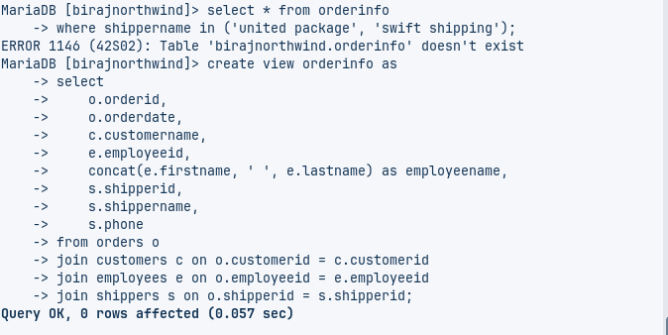
3. List all order shipment provided by United Package and Swift Shipping from **orderinfo**Query:  
     
     
     
   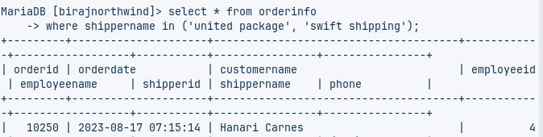

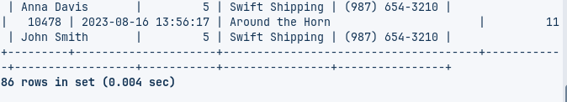

1. List all order processed by employee Janet Leverling and Steven Buchanan from **orderinfo**Query:

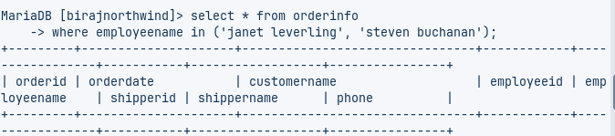

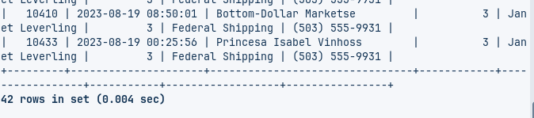

1. List all order shipment provider on date august 18 2023 from **orderinfo**Query:

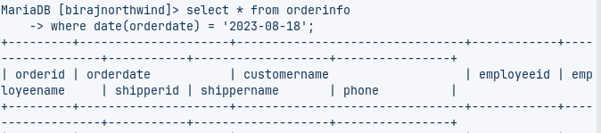

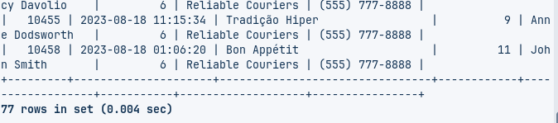

1. List countries of customers that placed order on august 19 2023 from **orderinfo**  
   Query:  
     
   